**ZC-H45-R3050 Mini PC With Nvidia RTX3050 Graphics GDDR6 4GB video memory,Intel 12th Gen Alder Lake-H 45W series CPU I3 I5 I7 I9**

**optional,1*LAN,2*HDMI 2.0,1*Type C,4*USB 3.0+2*USB 2.0**

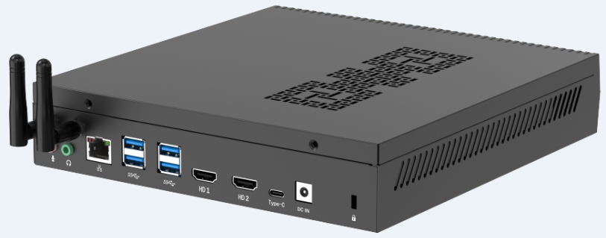

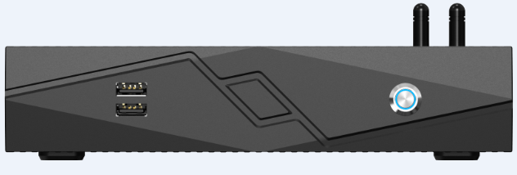

**Main Features:**

1.) Onboard Nvidia RTX3050 Discrete Graphics chip, GDDR6 4GB video memory

2.) Intel 12th Gen Alder Lake-H 45W series CPU, I3, I5, I7, I9 optional

3.) Dual channel SO-DIMM DDR4 2400/2666/3200MHz,up to 64GB

4.) Support 2*M.2 NVME high-speed SSD

5.) 2*HDMI 2.0 Ports,1*Type C

6.) High-performance heat pipe radiator, good heat dissipation effect

7.) Support wake-up on LAN, watchdog, GPIO, PXE diskless boot

**ZC-H45-R3050 Mini PC Specification**

|  |  |
| --- | --- |
| **CPU** | I5-12500H (12 Cores,3.3GHz Turbo to be 4.5GHz) |
| I7-12700H (14 Cores,3.5GHz Turbo to be 4.7GHz) |
| I9-12900H (14 Cores,3.8GHz Turbo to be 5GHz) |
| **RAM** | 2*SO-DIMM DDR4 2400/2666/3200,up to 64GB |
| **Storage** | 2*M.2 2280 NVME |
| **Graphics Card** | Nvidia RTX3050 Discrete Graphics chip, GDDR6 4GB video memory |
| **Network Card** | 1* Intel i226-V 2.5G |
| Support Wake On LAN,PXE |
| **I/O Ports** | 2*HDMI  2*USB 2.0  4*USB 3.0  1*Audio Out  1*MIC In  1*RJ45  1*Type C  1*DC Jack  1*Power Button  2*Antenna Holes |
| **Power Supply** | DC19V/7.89A |
| **Size** | 227*215*45mm |
| **OS** | Windows 10/11 / Linux |
| **Working Temp** | -10℃ to 60℃ |
| **Storage Temp** | -20℃～70℃ |
| **Relative Humidity Humidity** | 5%-95% relative humidity, no condensation |